**9. ReactJS-HOL**

1.Setup React App

|  |
| --- |
| npx create-react-app cricketapp |

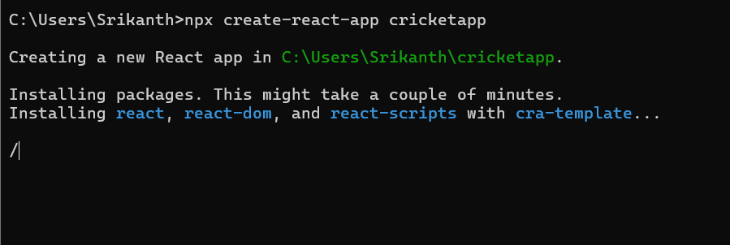

2. Create Components Folder

3. Create ListofPlayers.js in Components Folder

|  |
| --- |
| ListofPlayers.js  import React from 'react';  const ListofPlayers = () => {    const players = [      { name: 'Virat', score: 80 },      { name: 'Rohit', score: 45 },      { name: 'Rahul', score: 92 },      { name: 'Gill', score: 65 },      { name: 'Pant', score: 74 },      { name: 'Hardik', score: 88 },      { name: 'Jadeja', score: 56 },      { name: 'Ashwin', score: 68 },      { name: 'Bumrah', score: 90 },      { name: 'Shami', score: 35 },      { name: 'Kuldeep', score: 70 }    ];    const below70 = players.filter(player => player.score < 70); // using arrow function    return (      <div>        <h2>All Players</h2>        <ul>          {players.map((player, index) => (            <li key={index}>{player.name} - {player.score}</li>          ))}        </ul>        <h2>Players with score below 70</h2>        <ul>          {below70.map((player, index) => (            <li key={index}>{player.name} - {player.score}</li>          ))}        </ul>      </div>    );  };  export default ListofPlayers; |

4. Create IndianPlayers.js in Components Folder

|  |
| --- |
| IndianPlayers.js  import React from 'react';  const IndianPlayers = () => {    const T20players = ['Rohit', 'Virat', 'Rahul'];    const RanjiTrophy = ['Prithvi', 'Karun', 'Abhimanyu'];    const allPlayers = [...T20players, ...RanjiTrophy]; // Merge using spread    const oddPlayers = allPlayers.filter((_, i) => i % 2 !== 0);    const evenPlayers = allPlayers.filter((_, i) => i % 2 === 0);    return (      <div>        <h2>Merged Players</h2>        <ul>          {allPlayers.map((player, index) => (            <li key={index}>{player}</li>          ))}        </ul>        <h2>Even Team Players</h2>        <ul>          {evenPlayers.map((player, index) => (            <li key={index}>{player}</li>          ))}        </ul>        <h2>Odd Team Players</h2>        <ul>          {oddPlayers.map((player, index) => (            <li key={index}>{player}</li>          ))}        </ul>      </div>    );  };  export default IndianPlayers; |

5.Update App.js

|  |
| --- |
| App.js  // src/App.js  import React from 'react';  import ListofPlayers from './components/ListofPlayers';  import IndianPlayers from './components/IndianPlayers';  function App() {    const flag = true;    return (      <div className="App">        <h1> Cricket App</h1>        {flag ? <ListofPlayers /> : <IndianPlayers />}      </div>    );  }  export default App; |

6. Run the App

|  |
| --- |
| npm start |

**OUTPUT:**

**When flag is true:**

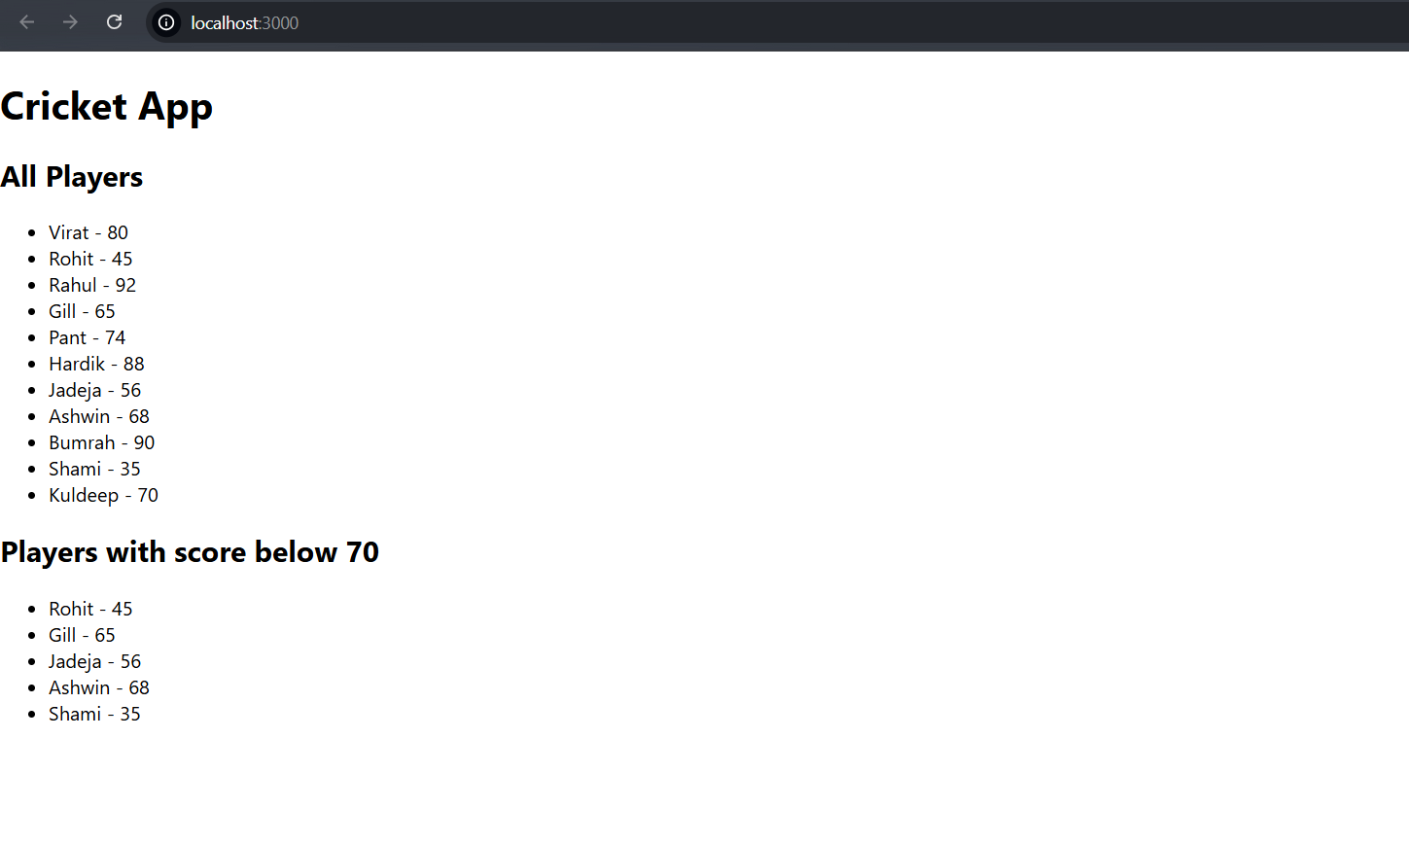

**When flag is false:**

